Deliverable 1.2

Requirement

1. 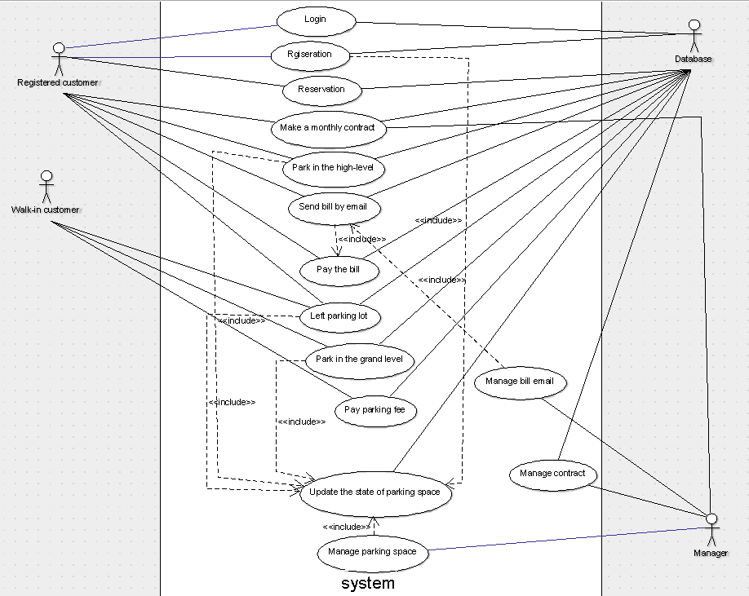Use case diagram
2. Use case elaboration

|  |  |
| --- | --- |
| Name | Login |
| ID | 1 |
| Description | Register customer login the reservation system |
| Primary Actor | Register customer |
| Secondary Actor(s) |  |
| Pre-condition | The database contains the user registration information |
| Post-condition |  |
| Trigger | User wants to make a reservation |

|  |  |
| --- | --- |
| Name | Registeration |
| ID | 2 |
| Description | Customer register as user in the system |
| Primary Actor | Register customer |
| Secondary Actor(s) |  |
| Pre-condition | User does not exist |
| Post-condition | User’s information saves in the database |
| Trigger | Customer wants to access to the reservation system |

|  |  |
| --- | --- |
| Name | Reservation |
| ID | 3 |
| Description | Register customer can make parking reservation in the system. |
| Primary Actor | Register customer |
| Secondary Actor(s) |  |
| Pre-condition | 1. 1. There is empty parking space in the parking lot 2. Register customer need provide parking plan and plate number |
| Post-condition | 1. Parking plan and plate number save in the database 2. The state of parking space has been updated to “reserved” |
| Trigger | Register customer have a plan to park in the parking lot |

|  |  |
| --- | --- |
| Name | Park in the high-level |
| ID | 4 |
| Description | Register customer can park in the high-level of the parking lot. |
| Primary Actor | Register customer |
| Secondary Actor(s) |  |
| Pre-condition | 1. Customer must be register customer 2. Register customer has made a reservation 3. Register customer provide parking plan and plate number at the entrance of the parking lot. 4. There is empty parking space in the high-level of parking lot. |
| Post-condition | 1. Parking plan and plate number save in the database 2. The state of parking space has been updated to “used” |
| Trigger | The sensor at the entrance detects the register customer |

|  |  |
| --- | --- |
| Name | Send bill by email |
| ID | 5 |
| Description | The system sends bill to register customer every month. |
| Primary Actor | Database |
| Secondary Actor(s) |  |
| Pre-condition | 1. Mail recipient must be register customer 2. Monthly fixed date |
| Post-condition | Register customer accepts the bill email |
| Trigger | The system sends email automatically by the fixed date of each month |

|  |  |
| --- | --- |
| Name | Pay the bill |
| ID | 6 |
| Description | Register customer can read and pay the bill by clicking the link in the email. |
| Primary Actor | Register customer |
| Secondary Actor(s) |  |
| Pre-condition | Register customer accepts the bill email. |
| Post-condition |  |
| Trigger | Register customer clicks the link in the email |

|  |  |
| --- | --- |
| Name | Left parking lot |
| ID | 7 |
| Description | Customer left the parking lot via exit |
| Primary Actor | 1. Register customer 2. Walk-in customer |
| Secondary Actor(s) |  |
| Pre-condition | 1. Customer is register customer 2. Walk-in customer has paid the parking fee |
| Post-condition | 1. The state of parking space has been updated to “empty” 2. The parking fee charged to bill |
| Trigger | The sensor at the exit detects the leaving customer |

|  |  |
| --- | --- |
| Name | Park in the grand level |
| ID | 8 |
| Description | Walk-in customer can only park in the grand level of the parking lot |
| Primary Actor | Walk-in customer |
| Secondary Actor(s) |  |
| Pre-condition | There is empty state parking space in the grand level of parking lot |
| Post-condition | The state of parking space has been updated to “used” |
| Trigger | The sensor at the entrance detects arrived customer |

|  |  |
| --- | --- |
| Name | Pay parking fee |
| ID | 9 |
| Description | Walk-in customer should pay parking fee before they leaving the parking lot |
| Primary Actor | Walk-in customer |
| Secondary Actor(s) |  |
| Pre-condition | Walk-in customer stays at the exit of parking lot |
| Post-condition |  |
| Trigger | The sensor at the exit detects the leaving customer |

|  |  |
| --- | --- |
| Name | Update the state of parking space |
| ID | 10 |
| Description | 1. The state of parking space will be change if the customer left the parking space 2. Manager can update the state of parking space in real time |
| Primary Actor | 1. Register customer 2. Walk-in customer |
| Secondary Actor(s) | Manager |
| Pre-condition | 1. Customer make reservation, park or leave 2. Manager update the state manually |
| Post-condition | The state of parking space has been updated |
| Trigger | Reservation, parking or leaving |

|  |  |
| --- | --- |
| Name | Manage parking space |
| ID | 11 |
| Description | Manager can read and search the state of parking space |
| Primary Actor | Manager |
| Secondary Actor(s) |  |
| Pre-condition |  |
| Post-condition |  |
| Trigger | Manager stays in the page of managing parking space |



|  |  |
| --- | --- |
| Name | Manage bill email |
| ID | 12 |
| Description | Manager sets the temple of the bill email and which date of every month to send the bill email |
| Primary Actor | Manager |
| Secondary Actor(s) |  |
| Pre-condition |  |
| Post-condition | The temple of email and date have been saved in the database |
| Trigger | Manager stays in the page of managing bill email. |

|  |  |
| --- | --- |
| Name | Make a monthly contract |
| ID | 13 |
| Description | Register customer can apply for a monthly contract with manager. Manager need to review the contract and pass the application. If register customer makes a contract, the fixed parking space will be reserved for him permanently |
| Primary Actor | Register customer |
| Secondary Actor(s) | Manager |
| Pre-condition | 1. Customer must be register customer 2. Manager passes the application |
| Post-condition | 1. The information of contract has been saved in the database 2. The parking space relates to the register customer |
| Trigger | Register customer apply for a contract |

|  |  |
| --- | --- |
| Name | Manage contract |
| ID | 14 |
| Description | Manager can read and search contract. |
| Primary Actor | Manager |
| Secondary Actor(s) |  |
| Pre-condition |  |
| Post-condition |  |
| Trigger | Manager stays in the page of managing contract |

1. UML Class Diagram

Quality Plan

1. Quality goals and metrics
2. Costs of quality